COINS-Constantine I (306-337), 317 AE Trier-Holding Globe

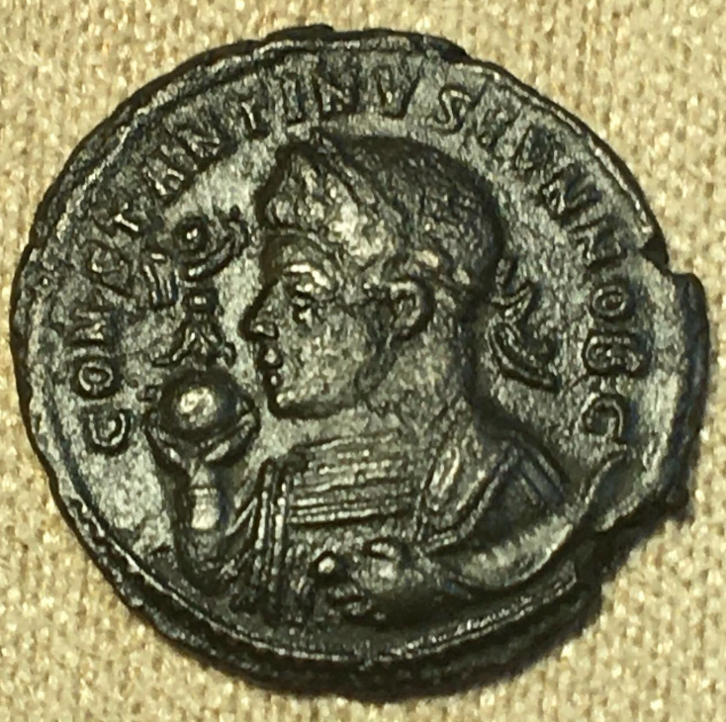 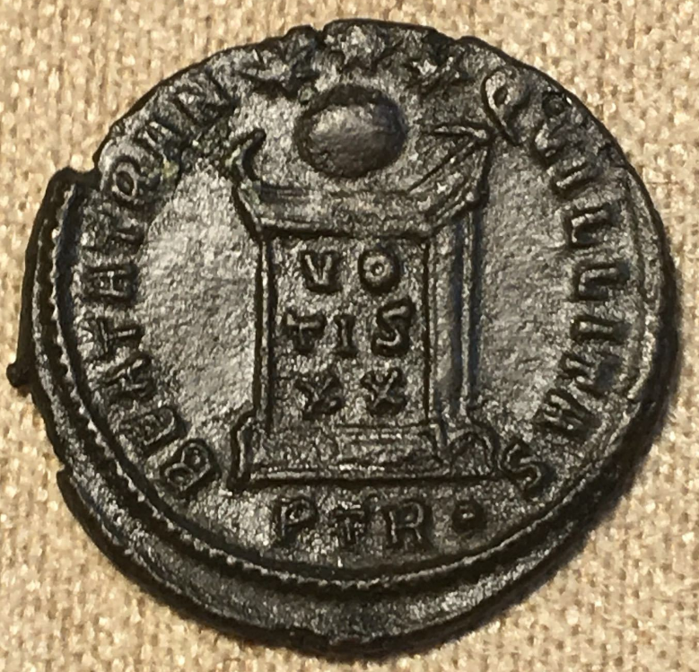

ROMAN EMPIRE

TREVERI, TRIER GERM

OFFICINA P (PRIMA OR 1)

COPPER 1 FOLLIE

EMPEROR CONSTANTINE

ND-306-337 AD

EF/EF+